1.Draw a labeled diagram of a typical home Wi-Fi setup showing a modem, router, switch, access point, and at least two devices (like a laptop and smartphone) connected to the network.

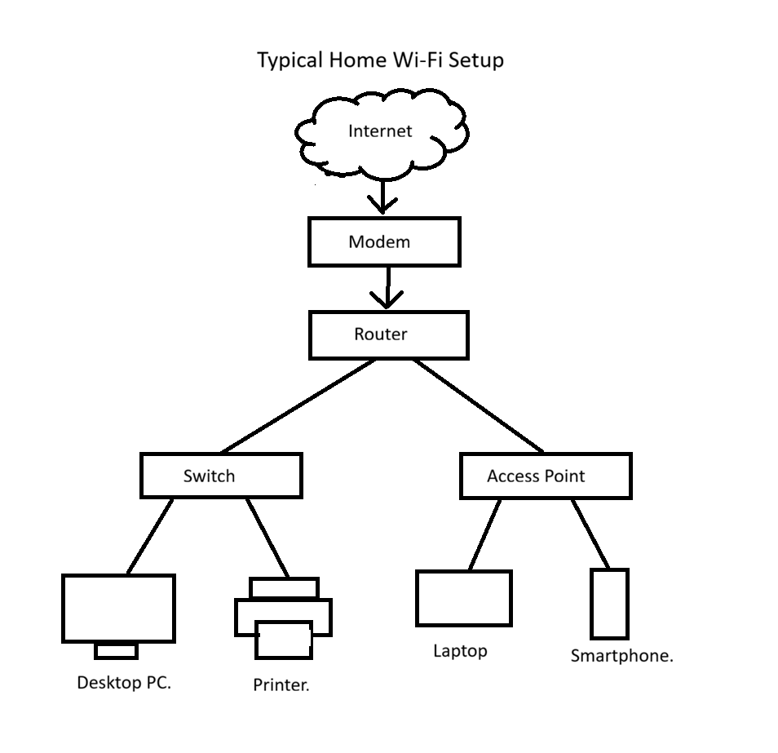

2.List the main function of each networking hardware device: modem, router, switch, access point, and network cable. For each, give a real-life example of where you might see or use it (for example, 'router: at home to share internet').

Device | Main Function | Real-life Example
Modem | A modem connects the home or office network to the Internet Service Provider (ISP). | At home, a modem is used to connect the internet provided by Jio, Airtel, or BSNL.
Router | A router shares the internet connection among multiple devices and manages network traffic. | At home, a router is used to share internet with laptops, smartphones, and smart TVs.
Switch | A switch connects multiple wired devices within the same network. | In a computer lab, a switch is used to connect many desktop computers.
Access Point | An access point provides wireless (Wi-Fi) connectivity to devices. | In colleges, offices, or malls, access points are used to provide Wi-Fi coverage.
Network Cable | A network cable transfers data between network devices through a wired connection. | Ethernet cables are used to connect a desktop computer to a router in homes and offices.

3.Take photos or find images online (with source links) of at least three types of network cables (such as Ethernet, coaxial, fiber optic) and write one line describingwhere each is commonly used.

Types of Network Cables

1. Ethernet Cable
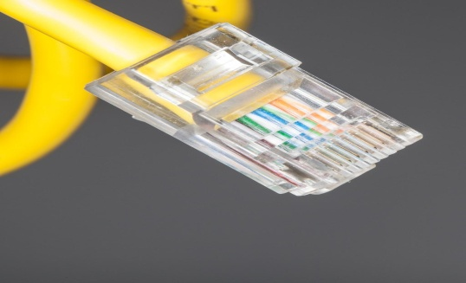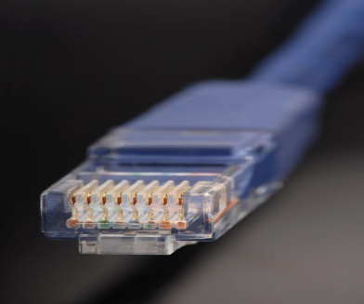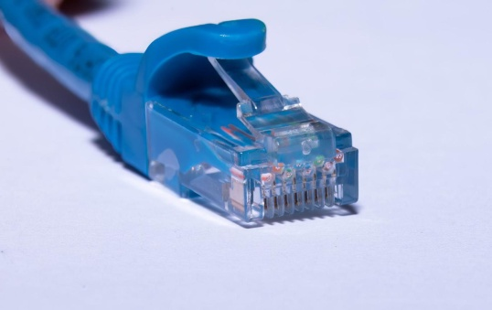
• Common Use: Ethernet cables are commonly used to connect computers, routers, and switches in homes, offices, and computer labs.
• Source Link: Ethernet Cable Images

2. Coaxial Cable

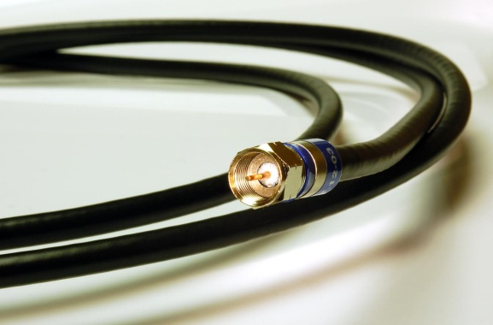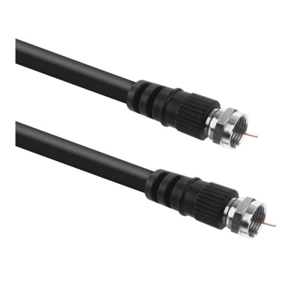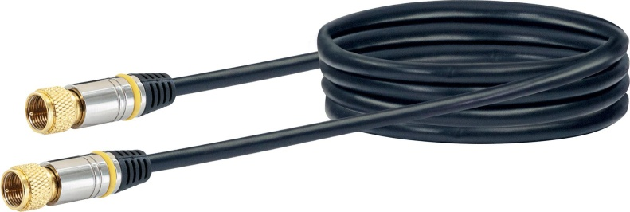

- Common Use: Coaxial cables are commonly used for cable TV connections and broadband Internet services.
- Source Link: Coaxial Cable Images

3. Fiber Optic Cable

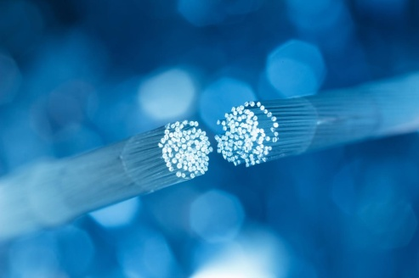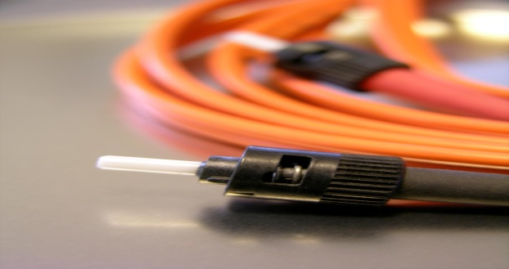
4.Create a comparison table listing at least four differences between a router and a switch, including their main use, typical location, and how they handle data.
Basis | Router | Switch
Main Use | A router connects different networks and shares the Internet connection. | A switch connects multiple devices within the same network.
Typical Location | Routers are commonly found in homes, offices, and schools. | Switches are commonly used in computer labs, offices, and large networks.
How They Handle Data | A router sends data packets between different networks using IP addresses. | A switch sends data only to the specific device using MAC addresses.
Internet Connection | A router can connect directly to the Internet through a modem. | A switch cannot connect directly to the Internet.
Number of Networks Connected | A router can connect two or more networks together. | A switch connects devices within a single network.

